Application
Prose PDU (Power Distribution Unit) provides various series of specifications with different functions, installation methods and plug combinations. The PDU is designed for power distribution in server racks, network cabinets, and data center equipment. It provides six UK 13A outlets for reliable power supply to multiple devices. The unit is equipped with a 16A 3-meter power cable with industrial connector plug and is suitable for rack-mounted applications.
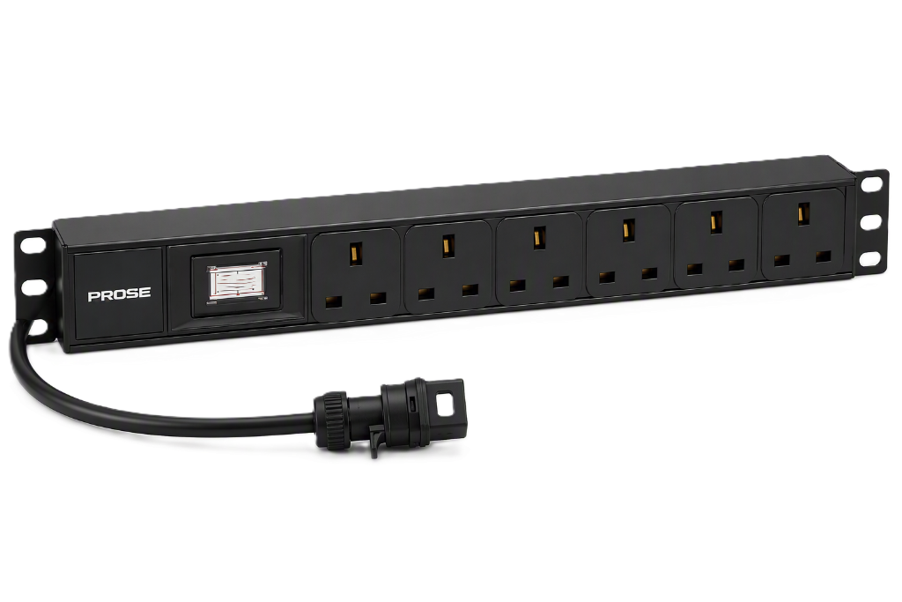



Characteristic
- Modular design，high compatibility and extensibility.
- Socket diversified, various sockets of different standard to meet the needs of different customers.
- Various power input，adopt GB plug, industrial coupler and other standard power input.
- Overload protection switch, prevent load short circuit and overload protection.
- Strong applicability, suitable for a variety of installation methods.
- 16A, 3-meter, 3-core input cable with industrial connector plug
- Main circuit breaker protection and power indicator
- Black housing with compact rack-mount design
- Operating temperature: -10°C to +45°C

PDU structure

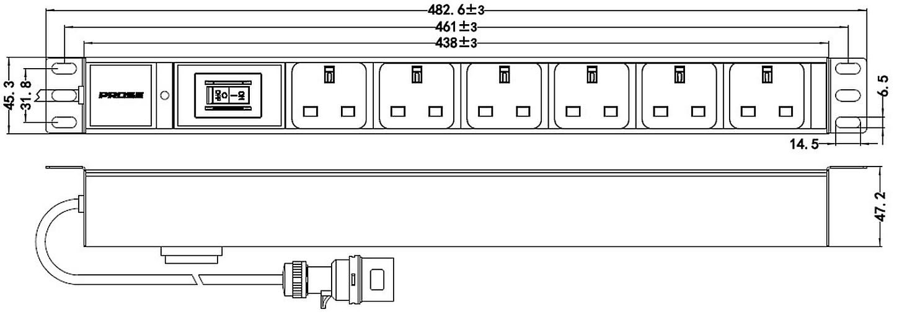

Technical Parameter
Parameter | Specification
PN | PU11-23016A-C06BH04
Rated Current (Ir) | 16A
Rated Voltage (Un) | 250VAC
Maximum Power (Pmax) | 4000W
Input | 16A, 3-meter 3-core cable with 16A industrial connector plug
Output | 6 × UK 13A outlets
Dielectric Strength (L/N-PE) | 1.5kV
Protection Features | Main circuit breaker protection and power indicator
Product Color | Black
Operating Temperature | -10°C to +45°C
Relative Humidity | 0% to 95% RH
Dimensions (L × W × H) | 482.6 × 45.3 ± 1 × 47.2 ± 1 mm
Mounting Dimensions | 461 × 31.8 ± 1 mm
Accessories | Mounting screws, 4 sets

GLOBAL FOOTPRINT
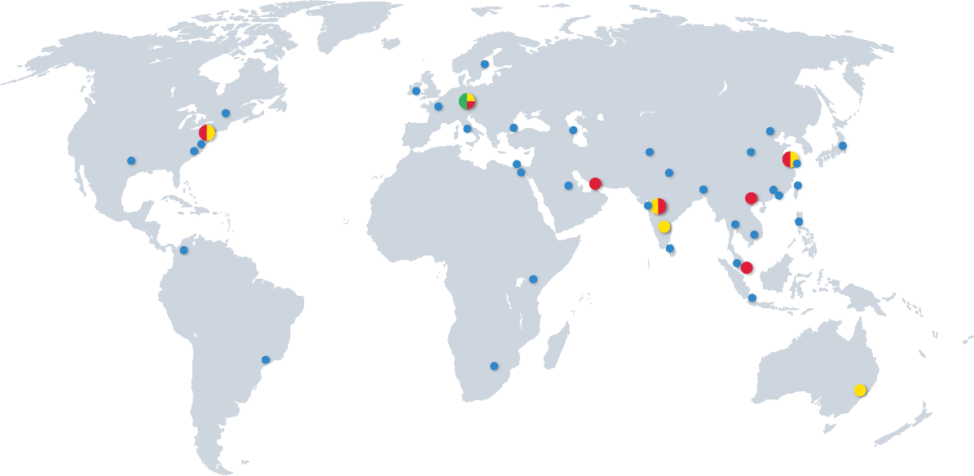

Headquarters | South Asia | South East Asia | East Asia
Donauwörth - Germany  PROSE Technologies GmbH  Add.: Dr.-Friedrich-Drechsler-Straße 14, 86609 Donauwörth, Germany  E-mail: info.eu@Prosetechnologies.com | Mumbai - India  PROSE Technologies India Private Limited  Add.: 403-407, Eco Star, Vishveshwar Nagar, Goregaon East, Mumbai ,India 400063  Tel: +91 22-66453000  E-mail: info.in@prosetechnologies.com  Pune - India  PROSE Technologies India Pvt.Ltd  Add.: A-79, Block-A , Horizon Industrial Parks, Phase II, MIDC Chakan Industrial Area, Khed, Pune , India 410501  Tel: +91 2135-635200  E-mail: info.in@prosetechnologies.com  Bangalore - India  PROSE Technologies India Private Limited  Add.: No.494 East End Main Road, Jayanagar IX Block, Bangalore, India 560069  E-mail: info.in@prosetechnologies.com  New Delhi - India  PROSE Technologies India Pvt.Ltd  Add.: H-3/157, 2nd Floor, Vikas Puri, New Delhi, India 110018  E-mail: info.in@prosetechnologies.com  Dhaka - Bangladesh  PROSE Technologies (Bangladesh) Limited  Add.: House-360 (2nd Floor), Lane-5 (East), Baridhara DOHS, Dhaka-1206, Bangladesh  Tel: +880 1977070130  E-mail: info.bd@prosetechnologies.com  Islamabad - Pakistan  Add.: Unit 514, 5th Floor, ISE Towers, Islamabad, Pakistan  Tel: +92 3335357733  E-mail: info.pk@prosetechnologies.com  Sri Lanka  Tel: +880 1977070130  E-mail: info.lk@prosetechnologies.com | Selangor - Malaysia  PROSE Technology (M) Sdn. Bhd  Add.: Unit 2-1, Level 2, The Podium, Tower 3, UOA Business Park, No 1, Jalan Pengaturcara U1/51a, Seksyen U1, 40150 Shah Alam, Selangor, Malaysia  Tel: +60 126859319  E-mail: info.my@prosetechnologies.com  Bangkok - Thailand  PROSE Technology (Thailand) Co., Ltd  Add.: 349 SJ Infinite I Business Complex,9 Floor, Room 905, Vibhavadi Rangsit Road, Chom Phon Sun-district, Chatuchak District, Bangkok Provice, Thailand  Tel: +66 80 6606630  E-mail: info.th@prosetechnologies.com  Singapore  PROSE Technologies (Singapore) Pte.Ltd  Add.: 10 Anson Road#13-15 International Plaza Singapore 079903  Tel: +6598366793  E-mail: info.sg@prosetechnologies.com  Hanoi - Vietnam  PROSE Technologies (Vietnam) Company Limited  Add.: Floor 15, Vinaconex 9 Building, HH-2 Block, Pham Hung Street, Me Tri Ward, Nam Tu Liem District, Hanoi, Vietnam  Tel: +84 933086498  E-mail: info.vn@prosetechnologies.com  Taguig - Philippines  PROSE Technologies Philippines, Inc.  Add.: Unit 17 19th Floor Highstreet South Corporate Plaza Tower 1, 26th Street corner 9th Avenue, Bonifacio Global City, Taguig City, Philippines  Tel: +63 27572762  E-mail: info.ph@prosetechnologies.com  Jakarta - Indonesia  PT. PROSE Technologies Indonesia  Add.: Plaza Sentral 6th Floor, Jalan Jenderal Sudirman No. 47, Jakarta 12930, Indonesia  Tel: +62 21 57901997  E-mail: info.id@prosetechnologies.com | Suzhou - China  PROSE Technologies (Suzhou) Co.,Ltd  Add.: No. 6, Shen’an Road, DianShanHu, Suzhou, JiangSu, China  E-mail: Info@prosetechnologies.com  Beijing - China  PROSE Technologies (Beijing) Co.,Ltd  E-mail: Info@prosetechnologies.com  Shanghai - China  PROSE Technologies (Shanghai) Co.,Ltd  E-mail: Info@prosetechnologies.com  Dongguan - China  Add.: Room 1506, building 1, No. 1, Yile Road, Songshanhu Park, Dongguan City, Guangdong Province, China  E-mail: Info@prosetechnologies.com  Hongkong - China  PROSE Technologies Company Limited  Add.: Unit B 13/F,Prat Commercial Building, 17-19 Prat Avenue, Tsimshatsui, Kowloon, HongKong, China  Tel:+86 512 86896789 - 2921/2922  E-mail: info.hk@prosetechnologies.com  Taiwan  Tel: +63 2 7572762  E-mail: info.tw@prosetechnologies.com
Western Europe
Dublin - Ireland
PROSE Technologies (Ireland) Limited
Add.: 6th Floor, South Bank House, Barrow Street, Dublin 4 Ireland
E-mail: Info@prosetechnologies.com
Eastern Europe & Central Asia
E-mail: info.eeca@prosetechnologies.com
North America
New Jersey - America
PROSE Technologies LLC
Add.: 550 Clark Drive Budd Lake, NJ 07828, United States of America
Tel: +1 888 840 4066
E-mail: info.us@prosetechnologies.com
Middle East |  |  | Oceania
Dubai - UAE  PROSE Technologies DMCC  Add.: 3702, Mazaya Business Avenue BB2, JLT, Dubai  Tel: +971 4 3999168  E-mail: info.ae@prosetechnologies.com |  |  | New South Wales - Australia  PROSE Technologies (Australia) Pty. Ltd  Add.: 5/13 Boundary Rd, Northmead, NSW 2152, Australia  Tel: +61 2 78055523  E-mail: info.au@prosetechnologies.com
Africa
Nairobi - Kenya
PROSE Technologies Africa (PTY) Ltd
Tel: +254 780440410
E-mail: info.ke@prosetechnologies.com

Gauteng, (Johannesburg) - South Africa
PROSE Technologies Africa (PTY) Ltd
Add.: Building 20, Cambridge Office Park, 5 Bauhina Road, Highveld Techno Park Centurion, Gauteng 0169, South Africa
Mobile: +27 725554840
E-mail: info.za@prosetechnologies.com

