Application
Prose FTTH Fiber Distribution Box is designed for fiber termination, distribution, and management in access networks. It supports fiber splicing, splitting, storage, and subscriber connection. Suitable for both indoor and outdoor installations, it is widely used in residential, commercial, and FTTH deployment scenarios.
Key Features
- Supports up to 48 fiber cores for high-density FTTH applications
- Integrated design for splicing, splitting, routing, and storage
- Multiple cable entry ports for feeder and drop cable flexibility
- Made of high-strength flame-retardant material with reliable protection
- Supports wall-mounted and pole-mounted installation methods
Product Appearance
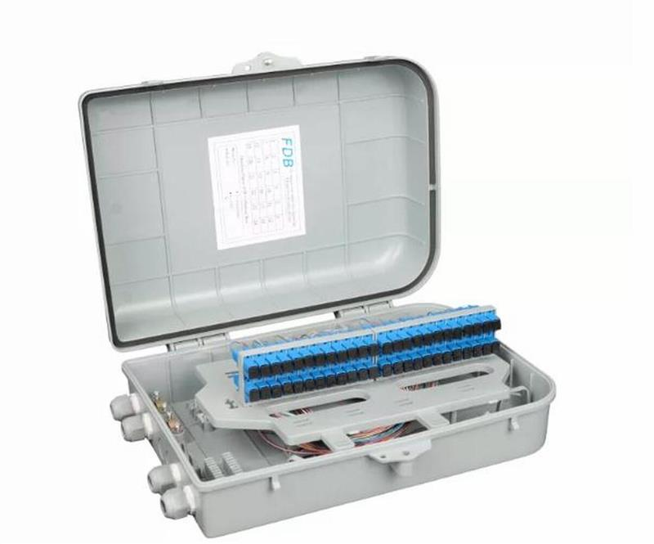
Technical Parameters
Material | ABS, PC+ABS
Dimensions | 355 × 270 × 120 mm
Fiber Capacity | 24F / 48F
Capacity | Supports up to 48 fiber adapters and pigtails
Waterproof Rating | IP65, IP66
Color | White, Black
Storage temperature range | -40°C to +70°C
Installation temperature range | -10°C to +60°C
Ordering Information
Part Number | Description
FBD-481-E | FTTH Fiber Distribution Box, 48 Port, White, Unloaded
FBD-481-SCGD1 | FTTH Fiber Distribution Box, 48 Port, with 48pcs SM SC Adapter & 48pcs SC SM Pigtail
GLOBAL FOOTPRINT

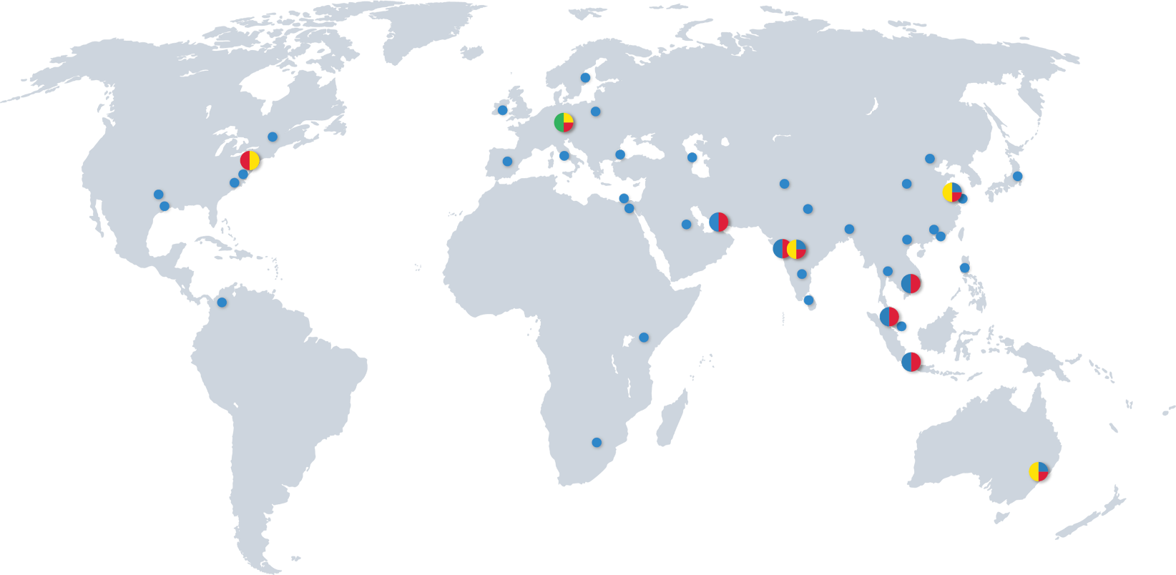

HQ
PRODUCTION / OPERATIONAL HUB
R&D / ENGINEERING
SUBSIDIARIES / SALES REPRESENTATIVES




PROSE Technologies
www.ProseTechnologies.com
info@ProseTechnologies.com
© 2026 PROSE Technologies
04/26
For more information
refer to our website

