Description
PROSE Fiber Optic Patch Cords provide high-performance optical connectivity for data centers, telecommunications, and enterprise networks. Featuring low insertion loss, high return loss, and precision-polished connectors, they ensure reliable and efficient signal transmission across a wide range of fiber optic applications.
Key Features
- PVC, LSZH and other outer sheath materials can be selected.
- OFNR, OFNP and other flame retardant grades can be selected.
- Low insertion loss, high return loss.
- Two types of end grinding mode: UPC, APC.
- Available with simplex cable, duplex cable, mini-zip cord cable, ribbon cable, other types of cables on request
- Separately packed in plastic bag, including serial number and attenuation data.
- Connector types: LC, SC, FC, ST, E200, MPO.
Profile/Outline
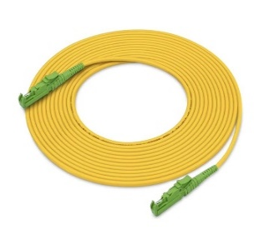
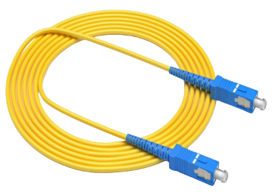
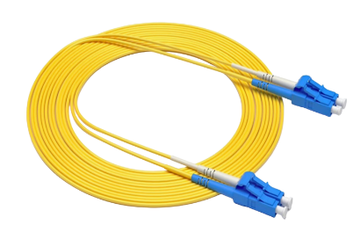

E2000-E2000
SC-SC
LC-LC

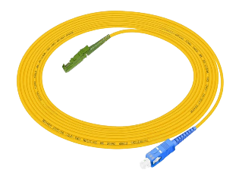
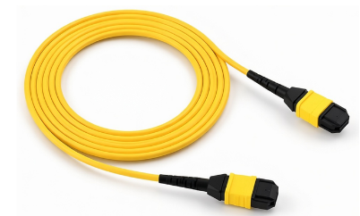
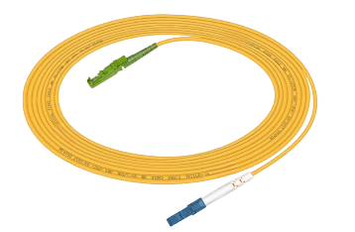

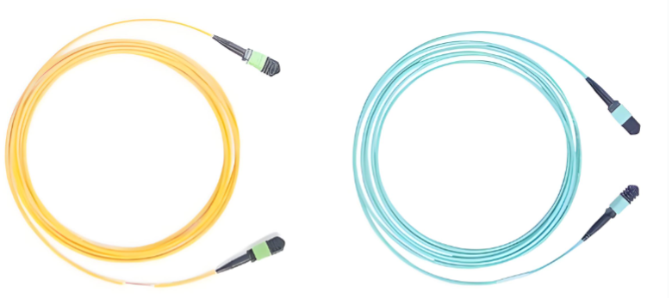

E2000-SC
E2000-LC
MPO-MPO

Technical Parameters
Fiber types | Single-mode 9/125um (G652D,G657A/B, etc.)  Multi-mode 50/125um (OM3/OM4/OM5)
Connecter variants | Simplex and duplex
External diameter | 0.9mm buffered fiber  2.0mm simplex/duplex cable  3.0mm simplex/duplex cable
Delivery form | Single item in foil bag  One product ID label with measurement values per patch cord  Serial number label on patch cord
Ferrule Outside Diameter (mm) | 1.25mm (LC); 2.50mm (SC)
Reference Standards
LC | Comply with IEC 61754-20
SC | Comply with TIA 568, IEC 874-10
FC | Comply with IEC 60874-7
ST | Comply with TIA 568, IEC 874-14
The insertion loss test | Acc.to IEC 61300-3-4
The return loss test | Acc.to IEC 61300-3-6
Optical cable parameters
Type |  | Insertion loss（dB） | Return Loss（dB）
SM:SC; FC; ST; LC,E2000 | Ultra (UPC) | ＜0.30 dB | ＞50 dB
SM:SC; FC; ST; LC,E2000 | Angle(APC) | ＜0.30 dB | ＞60 dB
MM:SC; FC; ST; LC,E2000 | Ultra (UPC) | ＜0.30 dB | ＞25 dB

Type | Parameters
Core | 1 | 2
Tensile strength (N) | 150 | 300
Compressive strength (N/cm) | 15 | 30
Minimum Bending Radius for Installation(mm) | 20 times O.D | 20 times O.D
Minimum Bending Radius for Operation (mm) | 10 times O.D | 10 times O.D
Installation Temperature(℃) | 0-50℃ | 0-50℃
Operating Temperature(℃) | -20 to +60℃ | -20 to +60℃
Transportation and Storage Temperature(℃) | -25 to +70℃ | -25 to +70℃
Ordering Information
Patch Cord  &Pigtail | Fiber Type | - | Fiber Count | Connector L | Connector R | Cable Structure | Outer Sheath | - | Length
FJ: Fiber Patchcord | GD:G652D  A1:G657A1  A2:G657A2  B2:G657B2  B3:G657B3  M2:OM2  M3:OM3  M4:OM4  M5:OM5 |  | 01:1F  02:2F  04:4F  06:6F  08:8F  12:12F | LC:LC UPC  SC:SC UPC  FC:FC UPC  ST:ST UPC  LA:LC/APC  SA:SC/APC  FA:FC/APC  MM:MPO Male  MF:MPO Female  E2:E2000/APC | 00:For Pigtail  LC:LC UPC  SC:SC UPC  FC:FC UPC  ST:ST UPC  LA:LC/APC  SA:SC/APC  FA:FC/APC  MM:MPO Male  MF:MPO Female  E2:E2000/APC | 1:0.9mm tight-buffered cable  2:2.0mm  3:3.0mm  4:2*2.0mm | 1:OFN  2:LSZH  3:OFNR  4:OFNP |  | 0005:0.5m  0010:1m  0050:5m  0100:10m  0150:15m  0200:20m
For Example:
Order Number | Description
Singlemode
FJGD-02LCLC42-0020 | Patchcord, Duplex, LC-LC, SM G652D, 2*2.0mm, LSZH, 2m
FJGD-01SCSC22-0020 | Patchcord, Simplex, SC-SC, SM G652D, 2.0mm, LSZH, 2m
FJGD-01LCSC22-0020 | Patchcord, Simplex, LC-SC, SM G652D, 2.0mm, LSZH, 2m
FJGD-01E2E222-0020 | Patchcord, Simplex, E2000-E2000, SM G652D, 2.0mm, LSZH, 2m
FJGD-01LCE222-0020 | Patchcord, Simplex, LC-E2000, SM G652D, 2.0mm, LSZH, 2m
FJGD-01SCE222-0020 | Patchcord, Simplex, SC-E2000, SM G652D, 2.0mm, LSZH, 2m
Multimode
FJM3-02LCLC42-0020 | Patchcord, Duplex, LC-LC, MM OM3, 2*2.0mm, LSZH, 2m
FJM3-01SCSC22-0020 | Patchcord, Simplex, SC-SC, MM OM3, 2.0mm, LSZH, 2m
FJM3-01LCSC22-0020 | Patchcord, Simplex, LC-SC, MM OM3, 2.0mm, LSZH, 2m
FJM3-01LCLC22-0020 | Patchcord, Simplex, E2000-E2000, MM OM3, 2.0mm, LSZH, 2m
FJM3-01LCE222-0020 | Patchcord, Simplex, LC-E2000, MM OM3, 2.0mm, LSZH, 2m
FJM3-01SCE222-0020 | Patchcord, Simplex, SC-E2000, MM OM3, 2.0mm, LSZH, 2m

GLOBAL FOOTPRINT

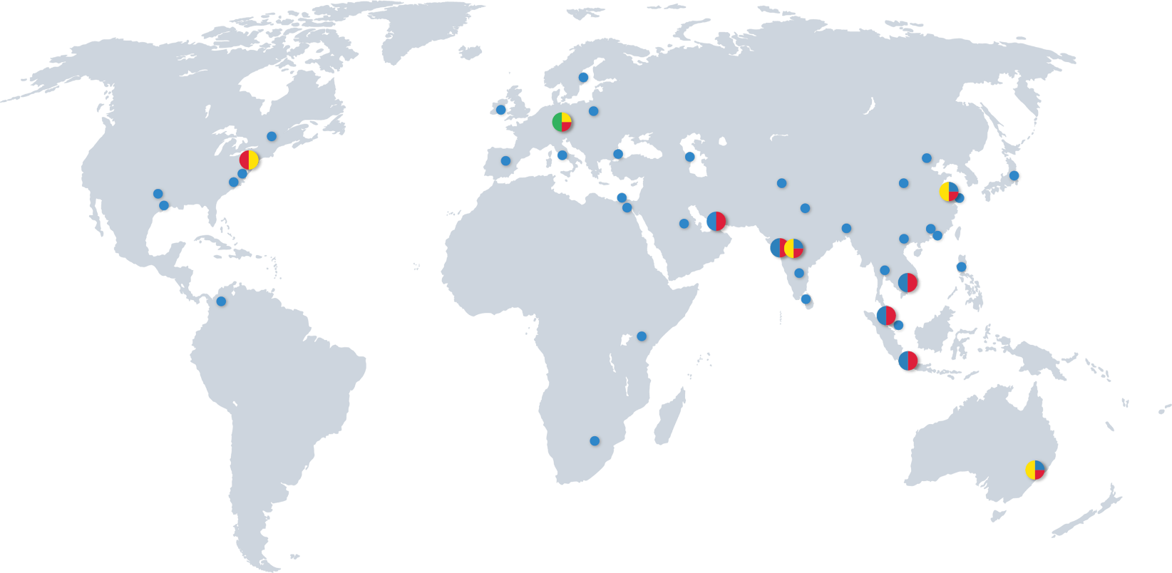

HQ
PRODUCTION / OPERATIONAL HUB
R&D / ENGINEERING
SUBSIDIARIES / SALES REPRESENTATIVES




PROSE Technologies
www.ProseTechnologies.com
info@ProseTechnologies.com
© 2026 PROSE Technologies
04/26
For more information
refer to our website

