Applications
PROSE optical fiber raceway is a set of products that can provide full protection for optical fibers and facilitate operation. The basic components include: channel body, connectors, horizontal elbows, vertical elbows, horizontal tees, horizontal crosses, vertical tees, adapters, terminal end caps, fiber outlets, bell mouths, and various support components. Featuring a standardized modular design with high engineering precision, it offers rapid, flexible, and comprehensive protection for optical fibers.

Characteristic
- Innovative design, full arc dead angle protection fiber optic cable.
- Tool-free installation, barrier-free connection.
- Multiple fiber outlet specifications to meet fiber requirements in various locations.
- Powerful compatibility, worry-free expansion.
- UL94-V0 highest-level flame-retardant material.

Straight.Duct
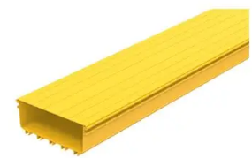
Straight Duct
Product Number | CR24-SD-111-11(Body) CR24-SD-110-11(Cover)
Size | 240mm (W) x 100mm (H) x 2000(mm) (L)
Flame retardant level | UL94-V0
External dimensions | Body: 1278×118×2000(mm), Cover: 274×12×2000(mm)
Maximum payout | 5800 strands (3 mm wire)

Duct Connector
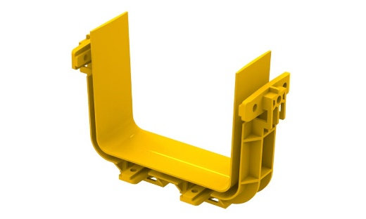
Duct Connector
Product Number | CR24-CO-211-11
Specification dimensions | 240×100(mm)
Flame retardant level | UL94-V0
Scope of application | Connection of components of 240-width Straight Duct
External dimensions | 287×60×119(mm)
Installation requirements | PR-LT5B4 Plastic round handle bolt ×8

Horizontal Corner Bend
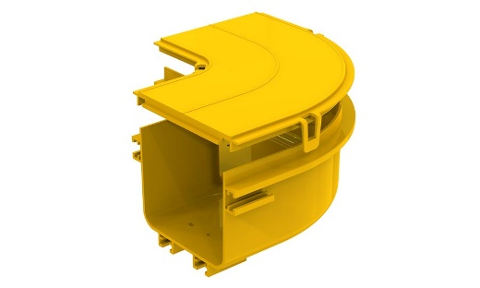
Horizontal 90° Corner Bend
Product Number | CR24-CB-311-11(Body), CR24-CB-310-11 (Cover)
Specification dimensions | 240×100(mm)
Flame retardant level | UL94-V0
Scope of application | Applicable to 240 series Straight Duct horizontal turns
External dimensions | Body: 347×347×121(mm), Cover: 381×381×37(mm)
Installation requirements | 2 sets of fittings; cover plate optional
Horizontal Tee
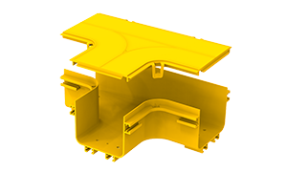
Horizontal Tee
Product Number | CR24-TE-411-11(Body), CR24-TE-410-11 (Cover)
Specification dimensions | 240×100(mm)
Flame retardant level | UL94-V0
Scope of application | Applicable to 240 series Straight Duct horizontal T-shaped connection
External dimensions | Body: 410×347×121(mm), Cover: 480×381×37(mm)
Installation requirements | 3 sets of fittings; cover optional

Horizontal Cross
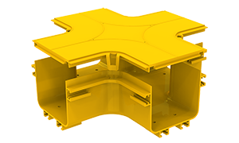
Horizontal Cross
Product Number | CR24-CR-511-11(Body), CR24-CR-510-11 (Cover)
Specification dimensions | 240×100(mm)
Flame retardant level | UL94-V0
Scope of application | Applicable to 240 series Straight Duct horizontal Cross
External dimensions | Body: 410×410×121(mm), Cover: 480×480×37 (mm)
Installation requirements | 4 sets of fittings; cover optional

End Closure
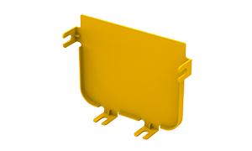
End Closure
Product Number | CR24-EC-611-11
Specification dimensions | 240×100(mm)
Flame retardant level | UL94-V0
Scope of application | Applicable to 240 series Straight Duct End Closure
External dimensions | 270×25×116(mm)
Installation requirements | - PR-LT5B4 Plastic round handle bolt ×4  - PR-LT338 Plastic square nut ×4

45° Upward Elbow
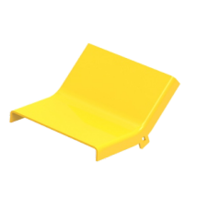
Product Number | CR24-AE-710-11 (Cover)
Specification dimensions | 240×100(mm)
Flame retardant level | UL94-V0
Scope of application | Applicable to 240 series Straight Duct 45° Upward Elbow
External dimensions | Body: 320×287×121(mm), Cover: 290×325×40(mm)
Installation requirements | 2 sets of fittings; cover optional
45° Upward Elbow
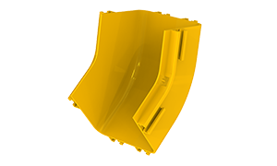
45° Upward Elbow
Product Number | CR24-AE-711-11(Body)
Specification dimensions | 240×100(mm)
Flame retardant level | UL94-V0
Scope of application | Applicable to 240 series Straight Duct 45° Upward Elbow
External dimensions | Body: 320×287×121(mm), Cover: 290×325×40(mm)
Installation requirements | 2 sets of fittings; cover optional

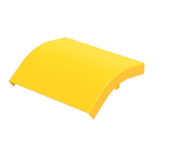
Product Number | CR24-AE-720-11 (Cover)
Specification dimensions | 240×100(mm)
Flame retardant level | UL94-V0
Scope of application | Applicable to 240 series Straight Duct 45° Downward Elbow
External dimensions | Body: 277×187×162(mm), Cover: 286×199×100(mm)
Installation requirements | 2 sets of fittings; cover optional
45° Downward Elbow

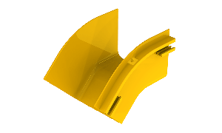
45° Downward Elbow
Product Number | CR24-AE-721-11(Body)
Specification dimensions | 240×100(mm)
Flame retardant level | UL94-V0
Scope of application | Applicable to 240 series Straight Duct 45° Downward Elbow
External dimensions | Body: 277×187×162(mm), Cover: 286×199×100(mm)
Installation requirements | 2 sets of fittings; cover optional

Waterfall Outlet
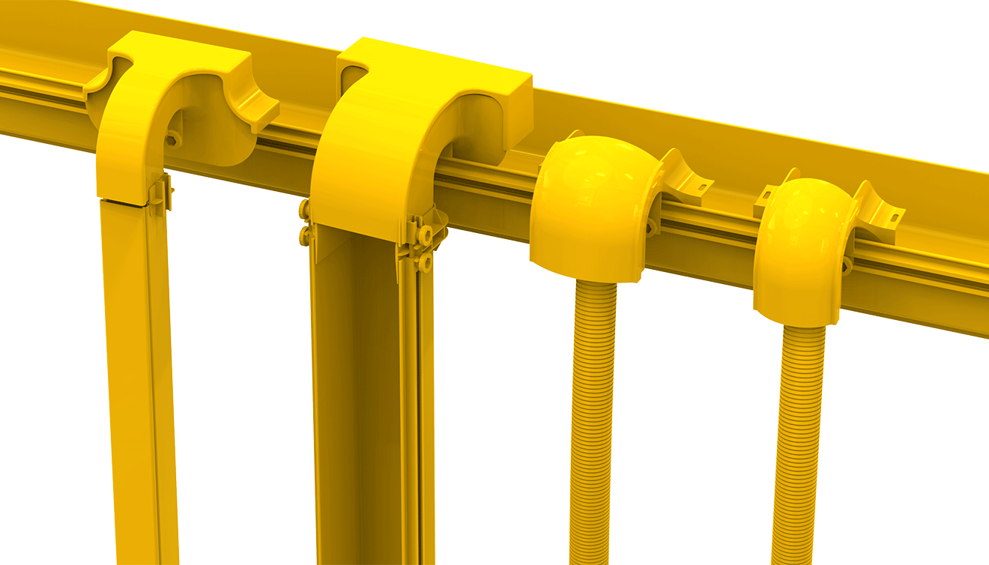
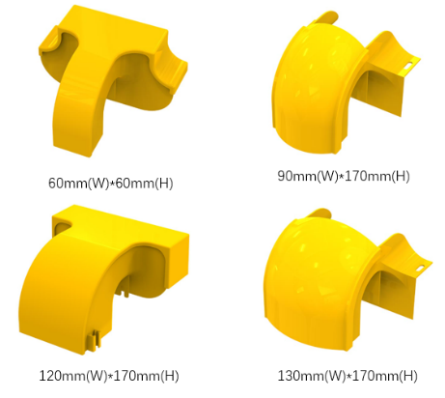
Series | 90*170mm Series | 120*170mm Series | 130*170mm Series
Product Number(Body) | CRAC-WO-851-11 | CRAC-WO-861-11 | CRAC-WO-871-11
Product Number(Cover) | CRAC-WO-850-11 | CRAC-WO-860-11 | CRAC-WO-870-11
External dimensions(Body) | 186×170×130mm | 250×211×146mm | 226×170×130mm
External dimensions(Cover) | 108×103×153mm | 258×260×149mm | 148×103×153mm
Flame retardant level | UL94-V0 | UL94-V0 | UL94-V0
Color | Yellow | Yellow | Yellow
Materials | PVC / ABS | PVC / ABS | PVC / ABS
Corrugated Tube Size | 55mm | 55mm/80mm | 55mm/80mm
Installation requirements | Round Plastic Screw with Nut ×2set

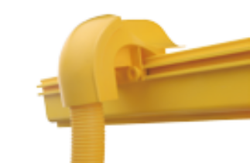

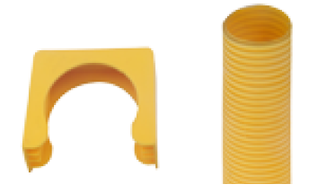
Corrugated Tube Kit
Product Number | CRACT-911-11(Φ55mm), CRACT-921-11(Φ80mm)
Color | Yellow
Materials | PVC / ABS
Installation requirements | Position fixer×1set

Screw and Nut
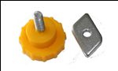

Round Plastic Screw and Nut
Product Number | CRAC-SN-211-11/CRAC-SN-221-11  CRAC-SN-221-11  CRAC-SN-221-11  CRAC-SN-221-11  CRAC-SN-221-11  CRAC-SN-221-11  CRAC-SN-221-11  CRAC-SN-221-11  CRAC-SN-221-11  /
Specification dimensions(mm) | M5×12(Screw); M5(Nut)
External dimensions(mm) | Φ25×24mm (Screw); 19×13x2.5mm (Nut)

Supporting Assembly
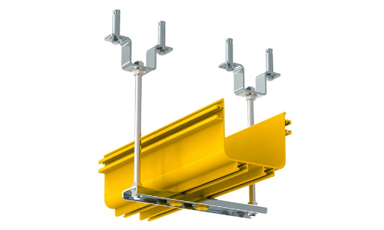
Product Number | CRAC-SA-XXX-XX
Accessories | - T-shaped Plastic Screw ×2  - Plastic knob Nut × 2  - “U” types of overhead cranes × 2  - Plastic double-hole crossarm × 1  - Expansion screws × 4  - Threaded rod × 2  - Flange nuts × 8

GLOBAL FOOTPRINT

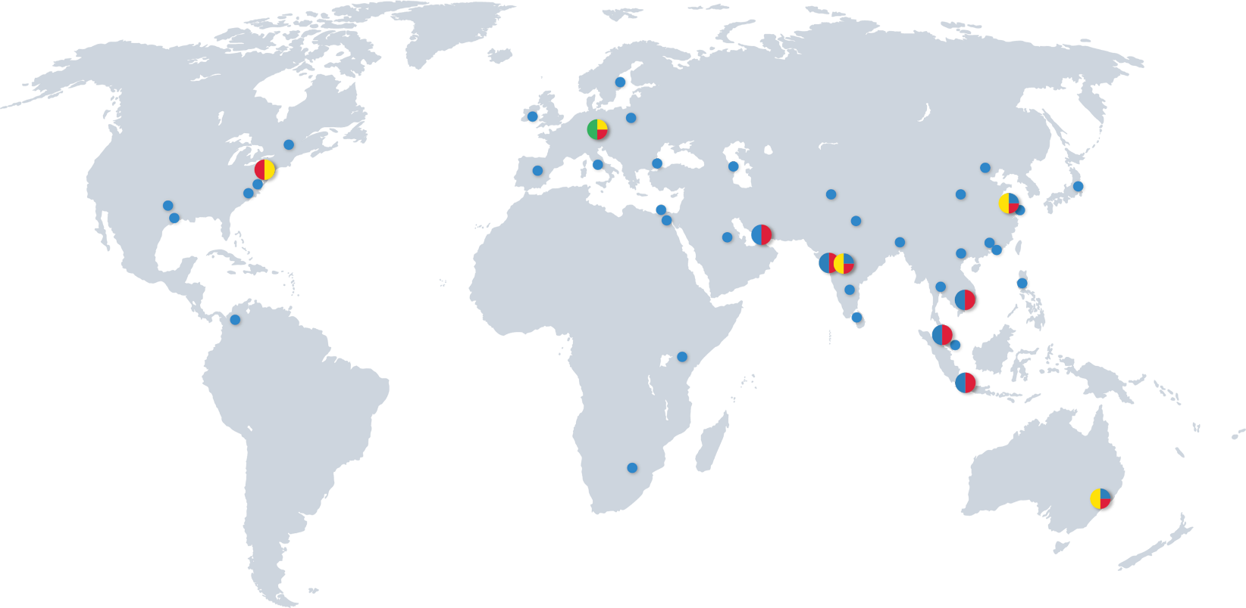

HQ
PRODUCTION / OPERATIONAL HUB
R&D / ENGINEERING
SUBSIDIARIES / SALES REPRESENTATIVES




PROSE Technologies
www.ProseTechnologies.com
info@ProseTechnologies.com
© 2026 PROSE Technologies
04/26
For more information
refer to our website

