Applications
PROSE Mesh Cable Tray is a professional cabling support system that provides reliable protection and convenient management for optical fibers and cables. It is widely used in data centers, communication rooms, and industrial/commercial scenarios. The basic components include: mesh cable tray bodies, connectors, elbows, tees, crosses, adapters, terminal end caps, fiber outlets, and various support components. With standardized modular design and high precision, it enables rapid, flexible installation and comprehensive protection for transmission lines.
Characteristic
- Innovative mesh design, ensuring good ventilation and heat dissipation to reduce energy consumption.
- Tool-free flexible installation, allowing on-site fabrication of elbows and easy component connection.
- Multiple fiber outlet and mesh cable tray specifications to meet diverse layout needs.
- Strong compatibility, supporting modular expansion and multi-scenario application.
- High-quality materials with certifications like UL, CE, ensuring safety and durability.
- Visual cable management and easy maintenance, with open mesh for clear internal inspection.
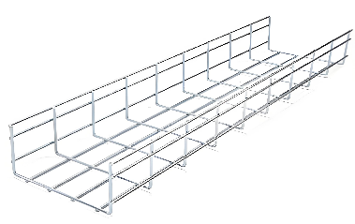
Straight Duct
Straight Duct
Product Number | CT20-U-055-13：200mm(W) x50mm(H)  CT30-U-055-13：300mm(W) x50mm(H)  CT40-U-055-13：400mm(W) x50mm(H)  CT50-U-055-13：500mm(W) x50mm(H)  CT20-U-105-13：200mm(W) x100mm(H)  CT30-U-105-13：300mm(W) x100mm(H)  CT40-U-105-13：400mm(W) x100mm(H)  CT50-U-105-13：500mm(W) x100mm(H)
Length | 3000mm
Materials | Q235(EZ)
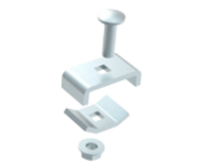
Connector

4

3
2

1

Mesh buckle kit
Product Number | CTAC-CO-3100-1
1 | M6×20 carriage bolt
2 | External buckle
3 | Internal buckle
4 | M6 flange nut
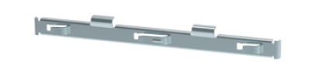
Quick connector kit
Product Number | CTAC-CO-3200-1
Scope of application and usage
50-300mm wide | Side: 2 sets of mesh quick connection strips; Bottom: None
400-500mm wide | Side: 2 sets of mesh quick connection strips; Bottom: 1 set of mesh buckle assembly
Width above 600mm | Side: 2 sets of mesh quick connection strips; Bottom: 2 set of mesh

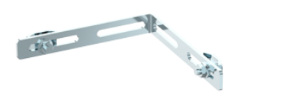
1

2

Product Number | CTAC-CO-3300-1
1 | Mesh L-shaped connector
2 | Mesh buckle assembly
L-shaped link kit

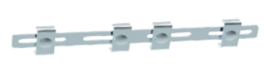
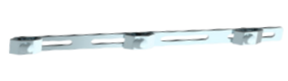
Reinforcement strip kit
3

2

1
Product Number | CTAC-CO-3400-1
1 | Mesh internal buckle assembly
2 | Mesh buckle assembly
3 | Mesh external buckle assembly

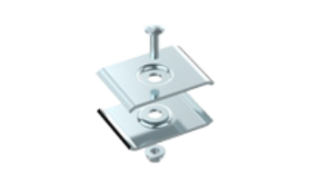
3

2

1
Central buckle kit
Product Number | CTAC-CO-3500-1
1 | M6×20 carriage bolt
2 | Mesh buckle assembly
3 | M6 hex flange nut


Curved reinforcement strip kit
2

1

Product Number | CTAC-CO-3600-1
1 | Curved reinforcement strip
2 | Mesh buckle assembly

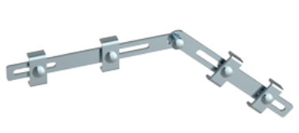
Inner and outer bend
reinforcement strip kit

3
1

2
Product Number | CTAC-CO-3700-1
1 | Inner and outer bend reinforcement strip
2 | External clip
3 | M6×20 carriage bolt and M6 flange nut

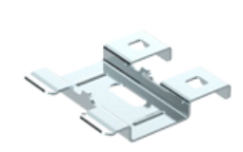
Boltless buckle
Product Number | CTAC-CO-3800-1
Boltless installation, used for the bottom connection when connecting mesh in a straight line horizontally.

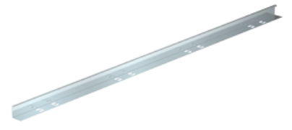
Mesh partition
Product Number | CTAC-CO-3900-1
Size | H40mm H50mm H60mm H75mm H100mm H150mm

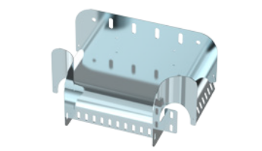
Cable outlet accessories

Product Number | CTAC-CU-41XX-1
Size | H100mm, W200mm H100mm, W300mm
Installation accessories | 4 M8×16 hex flange bolts and 4 M8 hex flange nuts
Mesh cable outlet

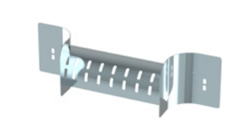

Product Number | CTAC-CU-4200-1
Installation accessories | 2 reinforced external clamps, 2 M8×16 hex flange bolts, and 2 M8 hex flange nuts
Lightweight grid outlet

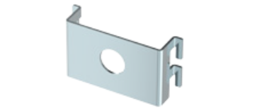
Pipe fixing plate
Product Number | CTAC-CU-43XX-1
Single-hole pipe fixing plate | φ17 φ21 φ25 φ32
Double-hole pipe fixing plate | φ17 φ21
Three-hole pipe fixing plate | φ21、φ25、φ32

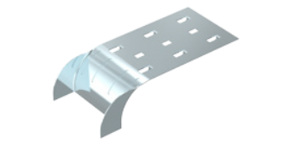
Product Number | CTAC-CU-44XX-1
Size | W45mm W90mm
Cable outlet plate

Cover
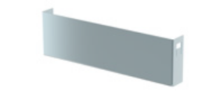
Mesh cable outlet
Product Number | CTAC-CU-51XX-1
Size | H50mm W100mm H50mm W150mm H50mm W200mm  H100mm W100mm H100mm W150mm H100mm W200mm  H100mm W300mm H100mm W400mm H150mm W300mm  H150mm W400mm H150mm W500mm H150mm W600mm

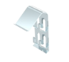
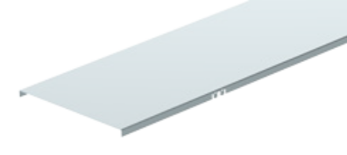
Product Number | CTAC-CU-52XX-1
Size | W50mm W100mm W150mm W200mm W300mm  W400mm W500mm W600mm
Mesh tray cover and cover clips

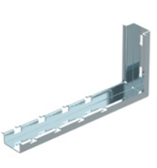
Wall-mounted Bracket

Product Number | CTAC-WB-61XX-1
Size | W100mm W150mm W200mm W300mm W400mm
L-shaped wall backing board

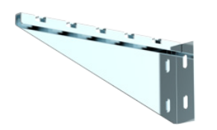

Product Number | CTAC-WB-62XX-1
Size | W100mm W150mm W200mm W300mm W400mm
Triangular wall backrest

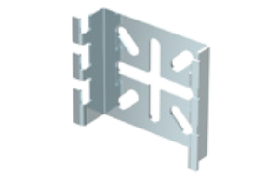

Product Number | CTAC-WB-6300-1
Size | H81mm W75mm
Spider Buckle

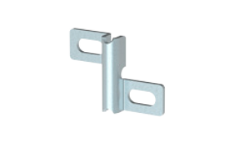

Product Number | CTAC-WB-6400-1
Size | 14.5mm * 51mm * 37mm (2mm thick)
Cross fixing plate

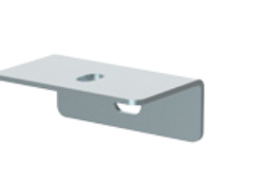

Product Number | CTAC-WB-6500-1
Size | W80mm W300mm W400mm
Right-angle wall backing board

Hanging Bracket
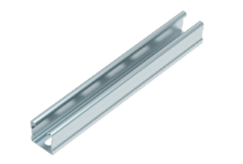
C-shaped cross bar
Product Number | CTAC-HB-71XX-1
Size | 10：W100mm；20：W200mm；30：W300mm  40：W400mm；50：W500mm；60：W600mm
Installation accessories | Fixing Clip Outer clamp M6×20 flange bolt M6 flange nut  Threaded rod

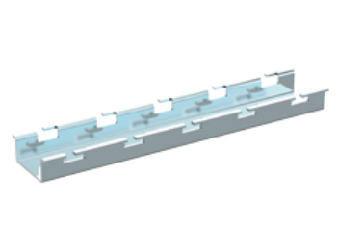
U-shaped cross bar
Product Number | CTAC-HB-72XX-1
Size | 10：W100mm；20：W200mm；30：W300mm  40：W400mm；50：W500mm；60：W600mm
Installation accessories | NA M6 flange nut Threaded suspension rod Kits

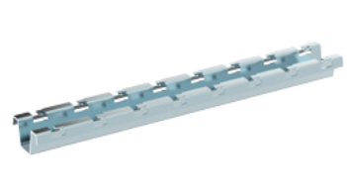
Product Number | CTAC-HB-73XX-1
Size | 10：W100mm；20：W200mm；30：W300mm  40：W400mm；50：W500mm；60：W600mm
Installation accessories | NA M6 flange nut Threaded suspension rod
M-shaped cross bar
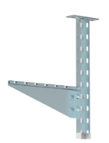

Product Number | CTAC-HB-7400-1
Component parts | Profile suspension rod Triangular plate wall support
Profile hanging kit

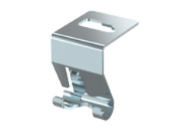
Product Number | CTAC-HB-7500-1
Installation accessories | M6 flange nut Threaded rod
Grid hook

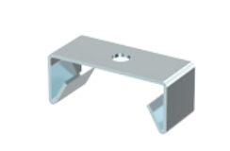
Grid hanging kit
Product Number | CTAC-HB-7600-1
Size | 73mm * 30mm * 30mm
Installation accessories | M6 flange nut Threaded rod

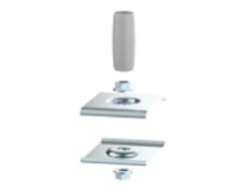
Product Number | CTAC-HB-7700-1
Installation accessories | M6 flange nut Threaded rod PVC pipe

Central snap




Product Number | CTAC-HB-7800-1
Size | U-Type M-Type Enhanced type
Purlin end cap

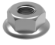
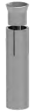
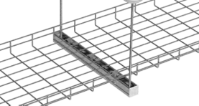
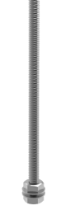
Lead screw kit
Product Number | CTSA-LS-XX*XXX
Size | M8*1000; M10*1000; M12*1000; M14*1000  M8*3000; M10*3000; M12*1000; M14*1000
Installation accessories | NA Expansion screw Nut

Floor Bracket
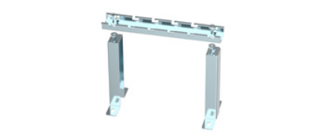
Product Number | CTAC-FB-81XX-1
Size | H:50mm 100mm 150mm 200mm  W:100mm 200mm 300mm 400mm 500mm 600mm
Installation accessories | M8×16 hex flange bolts M8 hex flange nuts
L-shaped wall backing board

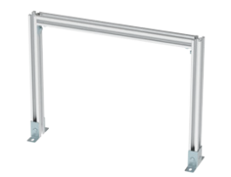

Product Number | CTAC-FB-8200-1
Installation accessories | M6×20 hex flange bolts M6 hex flange nuts Fixing Clip Outer clamp

Profile support kit
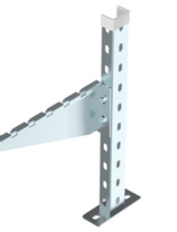

Product Number | CTAC-FB-8300-1
Component parts | Profile Hanger Rod Triangular wall brace

Profile support kit
(Triangular wall brace)
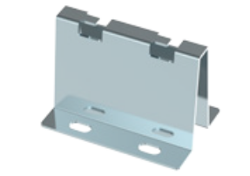

Product Number | CTAC-FB-8400-1
Size | W100mm W150mm W200mm
V-shaped support kit

GLOBAL FOOTPRINT

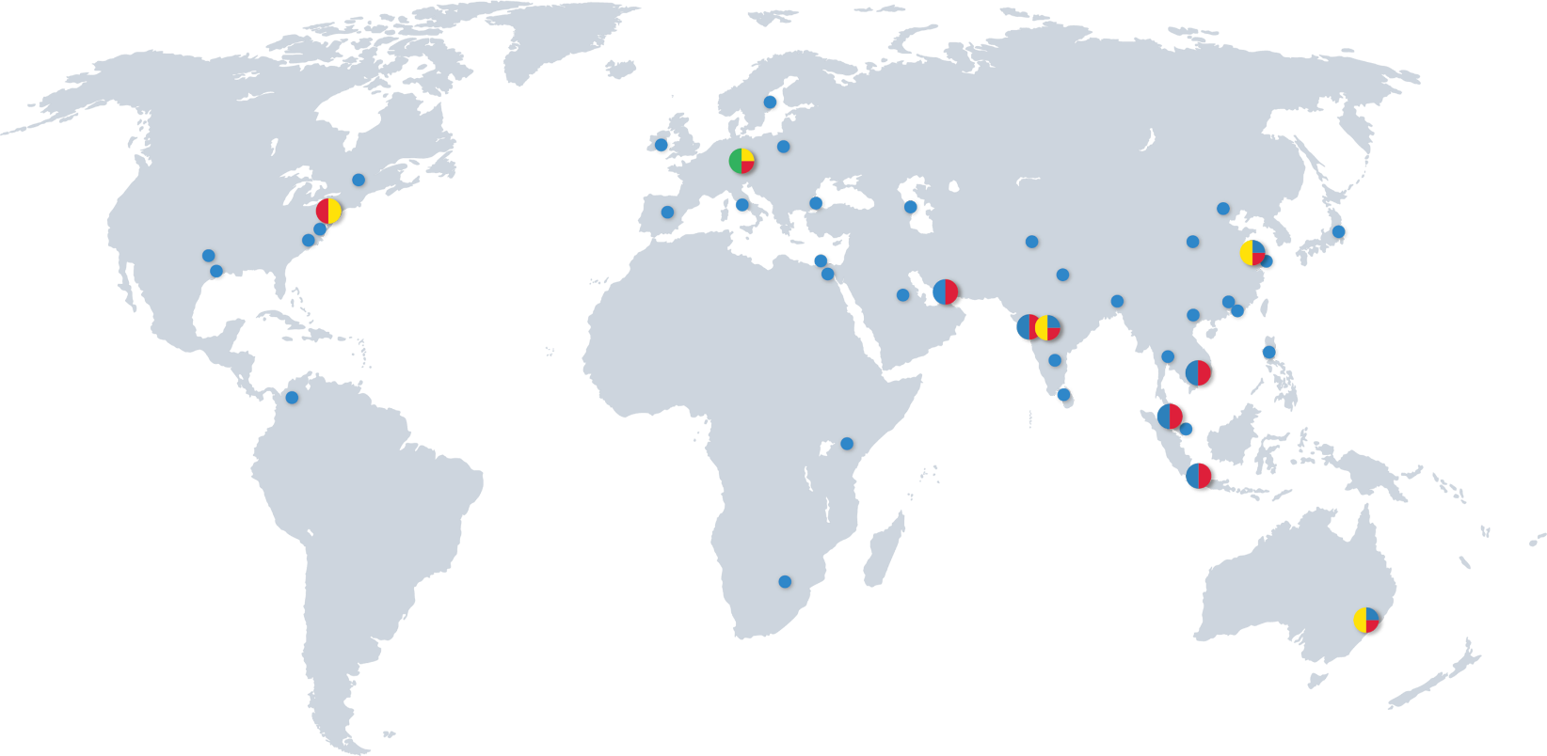

HQ
PRODUCTION / OPERATIONAL HUB
R&D / ENGINEERING
SUBSIDIARIES / SALES REPRESENTATIVES




PROSE Technologies
www.ProseTechnologies.com
info@ProseTechnologies.com
© 2026 PROSE Technologies
04/26
For more information
refer to our website

